ASD Smart Photo Book

UI Specification

Version 1.0

**Version History**

|  |  |  |  |
| --- | --- | --- | --- |
| **Date** | **Document Version** | **Contributor** | **Comments** |
| 8/28/2013 | 1.0 | Jim Emerson | First draft ready. |

Table of Contents

Introduction 6

PlayMemories UI 6

PlayMemories - Access and Sign In 6

PlayMemories - Library 7

PlayMemories - Albums 8

PlayMemories – Photo Books 9

Photo Book Activities 10

Creating a New Photo Book 10

Listing all Photo Books 10

Viewing a Photo Book 11

Sharing a Photo Book 11

Editing a Photo Book 11

Deleting a Photo Book 11

Photo Book Activity Flows 12

Photo Book UI Specifications 13

Photo Book Creation – UI Displays 13

Choose an Album 13

Choose Theme 14

Preview Photo Book 16

Photo Books List – UI Display 17

UI Components 17

Photo Book Views – UI Displays 18

Owner’s View 18

Non-Owner Friend’s Photo Book View 20

Photo Book Sharing – UI Displays 21

Sharing via Email 21

Sharing via Facebook 22

Manage Shared History 23

Photo Book Editing – UI Displays 25

Edit Photo Book Page 25

Photo Book Deleting – UI Displays 31

Selecting and Deleting a Photo Book 31

Selecting Any or All Photo Books for Deletion 32

Deleting Selected Photo Books 33

Appendix 34

A1. Photo Book Choose Album - Themes 34

Travel 34

Notebook 35

Cute 36

Crafty 36

Indie 37

Retro 38

Simple 38

Modern 39

A2.Terminology 40

Index 41

**FIGURES**

Figure 1. PlayMemories Access and Sign In 7

Figure 2. PlayMemories Library 7

Figure 3. PlayMemories Albums 8

Figure 4. PlayMemories Photo Books 9

Figure 5. Photo Book Activity Flows 12

Figure 6. PlayMemories – Photo Book - Choose An Album 13

Figure 7. PlayMemories - Photo Book – Choose Theme 14

Figure 8. Photo Book - Preview 16

Figure 9. PlayMemories – All Photo Books Listed 17

Figure 10. Photo Book – Owner View 18

Figure 11. Photo Book - Non-Owner's View 20

Figure 12. Share Photo Book - Email 21

Figure 13. Share Photo Book – Facebook 22

Figure 14. Manage Shared History 23

Figure 15. Photo Book – Edit Display 25

Figure 16. Photo Book - Edit – Change Theme 28

Figure 17. Delete Photo Book Prompt 31

Figure 18. Photo Book - List for Deletion 32

Figure 19. Photo Book - Permanently Delete Prompt 33

Figure 20. Travel Theme - Default Picture 34

Figure 21. Notebook Theme - Default Picture 35

Figure 22. Cute Theme - Default Picture 36

Figure 23. Crafty Theme - Default Picture 36

Figure 24. Indie Theme - Default Picture 37

Figure 25. Retro Theme - Default Picture 38

Figure 26. Simple Theme - Default Picture 38

Figure 27. Modern Theme - Default Picture 39

# Introduction

Integrated into ASD’s web-based PlayMemories (Online, Home, Studio, and Mobile), Smart Photo Book (SPB) enables a user to upload photos and incorporate them into a Photo Book in a few steps: select albums and photos, chose a theme for the Photo Book, preview and confirm the contents. Any time after creating Photo Books, users can edit, view, share, and delete them.

This document presents specifications for the PlayMemories Photo Book UI, focusing on.

* Photo Book UI Specifications
* Appendix – Shows default album images and defines SPB terms.

**Note**: This specification includes sample screen shots from an online Photo Book user. The same views will be seen by Mobile, Home, and Studio users.

## PlayMemories UI

The following sections introduce the pages and popups displayed for PlayMemories access/sign in and general features.

**Note**: Because this UI specification focuses on Photo Book, these introductory PlayMemories images are not described in detail.

### PlayMemories - Access and Sign In

Users access ASD PlayMemories to create, edit, share, and delete Photo Books at [www.playmemoriesonline.com](http://www.playmemoriesonline.com).

**Note**: This section only introduces the UI for accessing and signing in to PlayMemories.

When the user goes to the Play Memories URL, the access page appears.

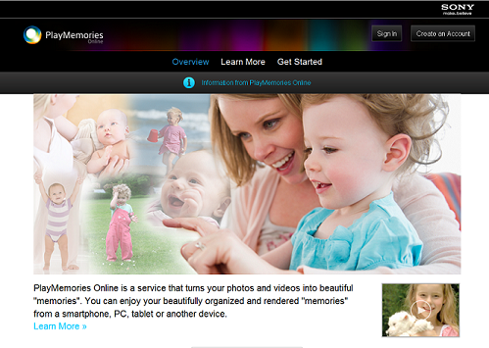

If the user clicks Sign In, a popup input form appears.

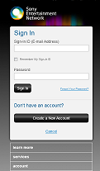

Figure 1.PlayMemories Access and Sign In

### PlayMemories - Library

After the user logs in, PlayMemories opens with the Library view. For example:

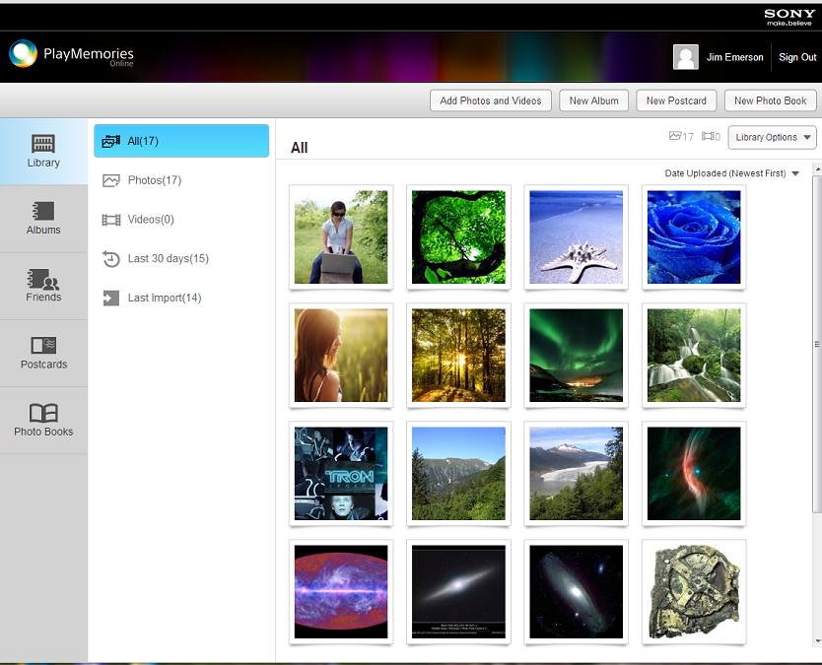

Figure 2.PlayMemories Library

From this page, the user can access Albums, Friends, Postcards, and Photo Books features.

### PlayMemories - Albums

The PlayMemories Albums view opens showing thumbnails representing all of the user’s albums. For example:

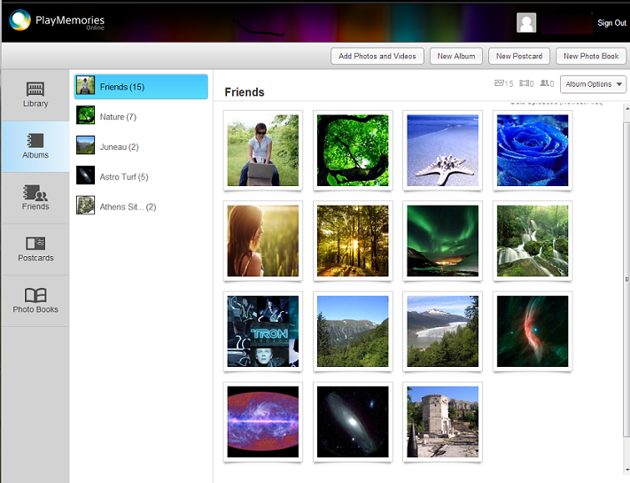

Figure 3. PlayMemories Albums

### PlayMemories – Photo Books

The PlayMemories Photo Books All list shows thumbnails representing all of the user’s Photo Books. For example:

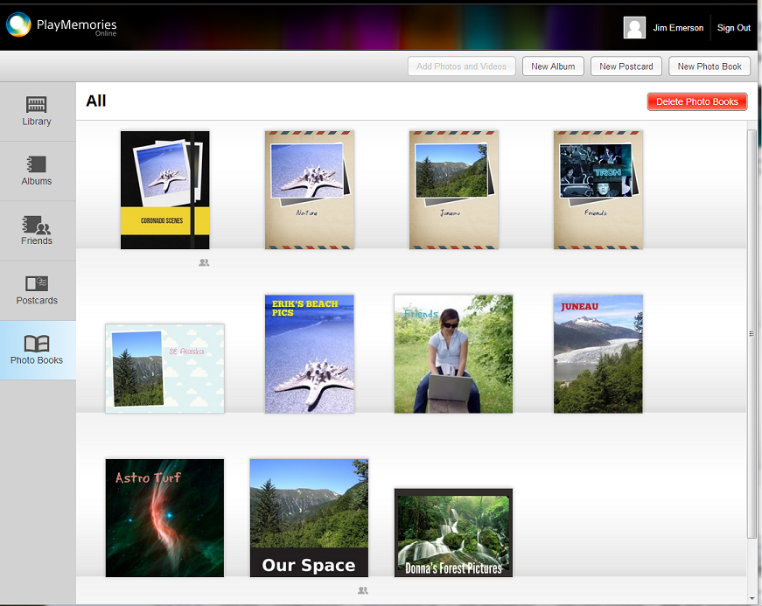

Figure 4. PlayMemories Photo Books

## Photo Book Activities

This section describes the user-controlled activity flows involved in creating, editing, sharing, and deleting a Photo Book. For a graphic overview of these flows, see .

Before users create and work with Photo Books, they:

* Create a ASD Entertainment account (e.g., Network Account for PlayMemories Online)
* Access and Sign In to ASD PlayMemories. See .
* Add photos and optionally, videos to PlayMemories.
* Create one or more PlayMemories Albums.
* And, optionally:
  + Add Friends (Share)
  + Add Postcards
  + Create another New Photo Book

For more information about these preliminary requirements, see the feature introductions at the ASD site <http://playmemoriesonline.com/leanmore>.

**Note**: Click a link to go directly to specification details.

### Creating a New Photo Book

1. User accesses the pages and signs in as the site owner or a visitor.

By default, the PlayMemories - Library page opens.

1. User clicks the New Photo Book link.
2. When popup appears, the user clicks the icon for a listed album.
3. When the window appears, the user selects a theme for the Photo Book. In this release, a   
   user can select one of the following theme types:
4. User previews the Photo Book and fills in a Photo Book Title.
5. User clicks Edit.

The new Photo Book appears.

1. Optionally, the user shuffles the photos, adds Decorations and supplementary Text, or adds more photos. See Editing a Photo Book.
2. User clicks Done to save the Photo Book.

The new book is listed in the display.

### Listing all Photo Books

* After signing in or on a Photo Books page, the user clicks the Photo Books link on the page.

The page appears showing thumbnails of all Photo Books.

### Viewing a Photo Book

1. After signing in or on a Photo Books page, the user clicks the Photo Books link on the page.
2. User clicks a Photo Book thumbnail link for a view.

The appears.

### Sharing a Photo Book

1. After signing in or on a Photo Books page, the user clicks the Photo Books link on the page.
2. User clicks a Photo Book thumbnail link to share the book.
3. When the Photo Book page appears, the user clicks either the email or Facebook icon: .



1. User fills in the email or Facebook address and clicks Send.

A message appears indicating that the Album is shared with the specified email address.

1. User clicks Done.

### Editing a Photo Book

1. After signing in or on a Photo Books page, the user clicks the Photo Books link on the page.
2. User clicks a Photo Book thumbnail link to edit the book.
3. When the Photo Book page opens the user clicks Edit under the Options pull-down menu.
4. User adds Pages, Photos, Decorations, or supplementary Text.
5. User clicks the Save icon .



### Deleting a Photo Book

1. After signing in or on a Photo Books page, the user clicks the Photo Books link on the page.
2. User clicks a Photo Book thumbnail link.
3. When the Photo Book page opens the user clicks the Delete under the Options pull-down menu.
4. When the prompt appears, the user clicks Delete.

These Photo Book activities are represented in the following process flow diagram.

## Photo Book Activity Flows

Photo Book creation, editing, sharing, and deleting activity flows are represented in the following figure.

**Note**: Expand the figure to see flow details.

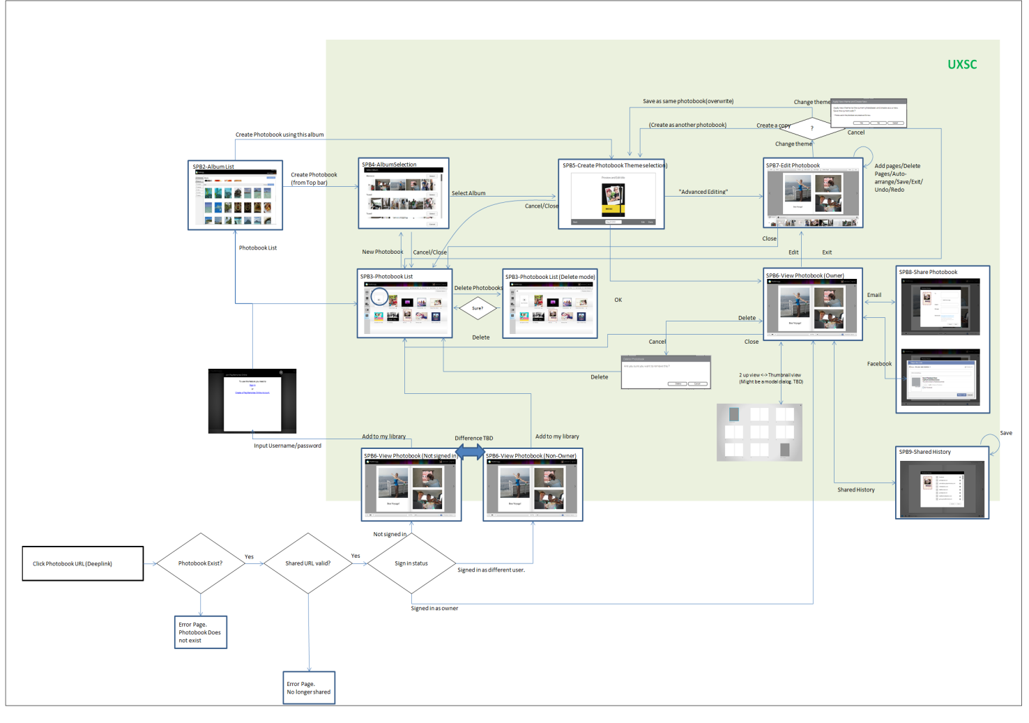

Figure 5. Photo Book Activity Flows

# Photo Book UI Specifications

PlayMemories users will be able to create, edit, share, and delete Photo Books. This section provides specifications for the UI pages and popups used in these activities.

## Photo Book Creation – UI Displays

To create a Photo Book, PlayMemories users will select one or more albums, select a theme, preview the new Photo Book, edit the Photo Book (if necessary), and save the result. The following sections provide specifications for UI pages and popups involved in these activities.

### Choose an Album

When the user clicks New Photo Book, PlayMemories displays the Choose an Album selection popup. For example:

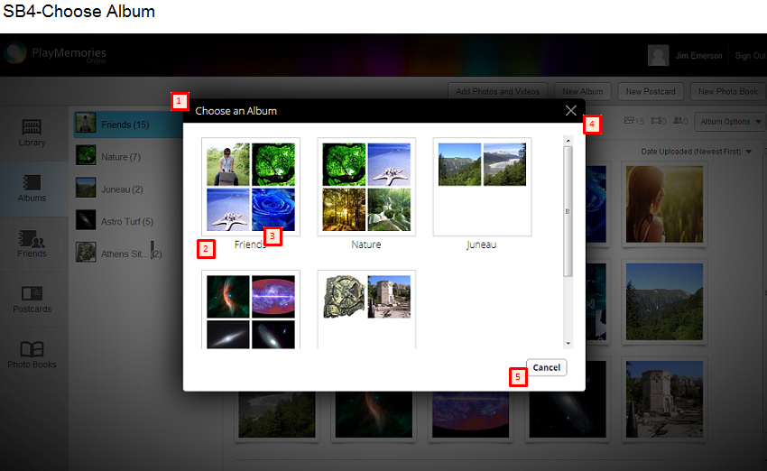

Figure 6. PlayMemories – Photo Book - Choose An Album

#### UI Components

The following table provides specification for the UI components in this display.

**Note**: Numbers in the left column refer to the red square numbers on the image above.

|  |  |  |  |  |  |
| --- | --- | --- | --- | --- | --- |
|  | **Control Type** | **Text (ENG)** | **Specification Behavior** | **Tool Tip (Mouse Over)** | **Note** |
| 1 | Title Bar | Choose an Album | Displays all existing albums. |  |  |
| 2 | Image |  |  | <ALBUM_TITLE> | Maximum four (4) photos per album. |
| 3 | Button |  | Selects the album. |  | User clicks the image button. |
| 4 | Button |  | Starts the close dialog and closes the window. | Close | User clicks the button. |
| 5 | Button | Cancel | Starts the close dialog and closes the window. | Cancel | User clicks the button. |

### Choose Theme

After the user clicks on an Album, the Choose Theme window opens. For example:

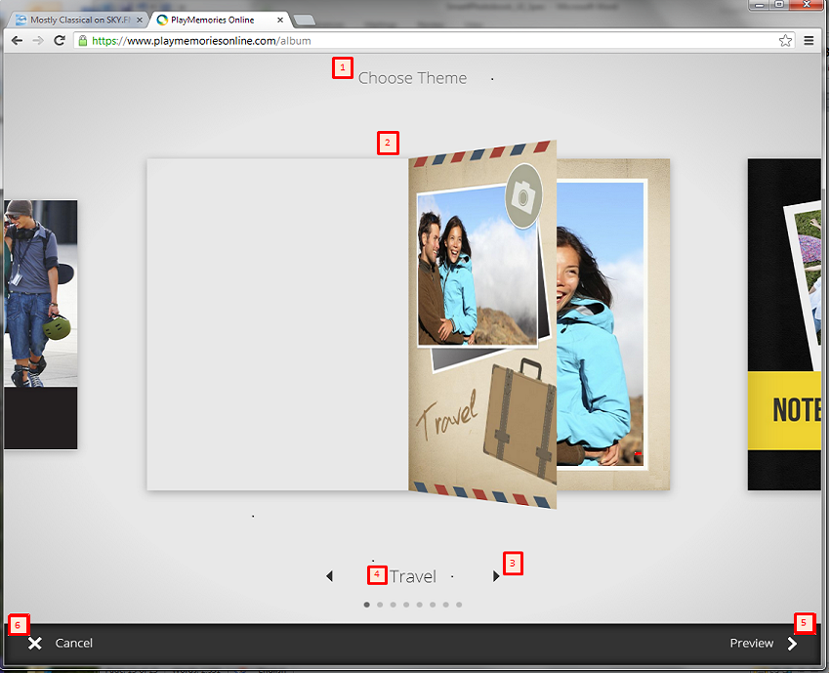

Figure 7. PlayMemories - Photo Book – Choose Theme

#### UI Components

The following table provides specification for the UI components in this display.

|  |  |  |  |  |  |
| --- | --- | --- | --- | --- | --- |
|  | **Control Type** | **Text (ENG)** | **Specification Behavior** | **Tool Tip (Mouse Over)** | **Note** |
| 1 | Text | Choose Theme |  |  |  |
| 2 | Image |  | Displays theme image.   * When the cursor touches the theme image, the page turns. * When the user clicks the image, a starts. |  | Window opens with the default image preselected. |
| 3 | Buttons |  | Moves theme display. |  | Arrow clicks change the displayed image. |
|  |  |  | Arrow click moves the display to the previous theme. | Previous Theme | User clicks: |
|  |  |  | Arrow click moves the display to the next theme. | Next Theme | User clicks: |
| 4 | Text |  |  |  | Theme name. |
|  |  | Travel |  | Share the photos from your adventures. | See for the default image. |
|  |  | Notebook |  | A theme inspired by your old school notebooks. | See for the default image. |
|  |  | Cute |  | A fun and playful theme great for your family albums. | See Cute for the default image. |
|  |  | Crafty |  | An arts and crafts theme to show off your creativity. | See Crafty for the default image. |
|  |  | Indie |  | A fashionable theme to bring out your fun side. | See Indie for the default image. |
|  |  | Retro |  | A vintage theme to place your memories in a time honored way. | See Retro for the default image. |
|  |  | Simple |  | A basic theme that is to the point. | See Simple for the default image. |
|  |  | Modern |  | A fresh and contemporary theme. | See Modern for the default image. |
| 5 | Button | Preview | Starts a of the current theme selection. | Preview theme with your photos. |  |
| 6 | Button | Cancel | Cancels the activity returns the display to . | Cancel |  |

### Preview Photo Book

When the user selects a theme PlayMemories generates a preview view. For example:

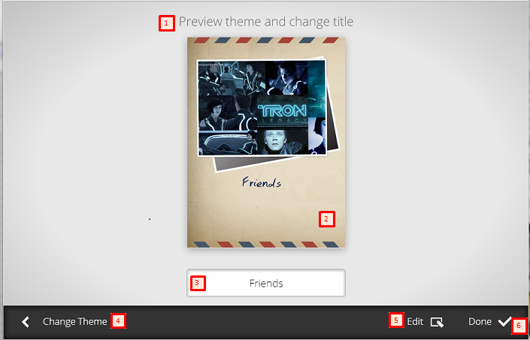

Figure 8. Photo Book - Preview

#### UI Components

The following table provides specification for the UI components in this display.

|  |  |  |  |  |  |
| --- | --- | --- | --- | --- | --- |
|  | **Control Type** | **Text(ENG)** | **Specification Behavior** | **Tool Tip (Mouse Over)** | **Notes** |
|  | Text | Generating Preview |  |  | This popup text not shown in this specification.The short message appears while the Photo Book preview is being created. |
| 1 | Test | Preview theme and change title |  |  |  |
| 2 | Image |  |  |  |  |
| 3 | Text Area | <ALBUM_TITLE> |  |  |  |
| 4 | Button | Change Theme | Moves activity back to . | Click here to select another theme. |  |
| 5 | Button | Edit | Saves current Photo Book and goes to the display. | Click here to edit this Photo Book. |  |
| 6 | Button | Done | Creates the Photo Book and changes to the display. | Create and view your new Photo Book. |  |
|  | Text | Now creating your Photo Book. |  |  | Popup text not shown in this specification. This short message appears while the new Photo Book is being created. |

## Photo Books List – UI Display

The user clicks on Photo Books to view a complete list of all his/her Photo Books. The displayed page shows thumbnails for each cover page. For example:

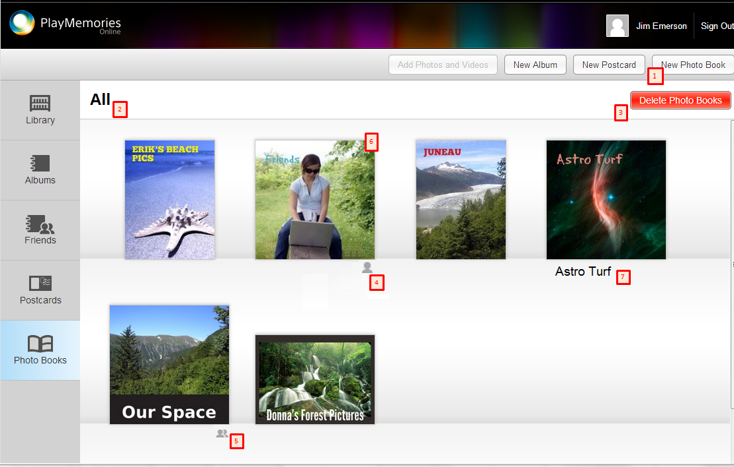

Figure 9. PlayMemories – All Photo Books Listed

### UI Components

The following table provides specification for the UI components in this display.

|  |  |  |  |  |  |
| --- | --- | --- | --- | --- | --- |
|  | **Control Type** | **Text(ENG)** | **Specification Behavior** | **Tool Tip (Mouse Over)** | **Note** |
| 1 | Text | Add New Photo Book | Moves display to Album Selection Dialog. | Add New Photo Book |  |
| 2 | Text | All |  |  |  |
| 3 | Button | Delete Photo Books | Moves display to delete mode | Enter delete Photo Book mode |  |
| 4 | Icon |  | Photo Book that was added to the user’s Library and not owned by the user |  | Shared from friend icon: |
| 5 | Icon |  | Photo Book shared to friend | You've shared this Photo Book. | Shared to friend icon: |
| 6 | Image |  | Moves display to "view Photo Book" when click | Open Photo Book: <PHOTO BOOK_TITLE> | Photo Book Cover page thumbnail |
| 7 | Text |  | Shows Album Title |  |  |

## Photo Book Views – UI Displays

When the user completes a new Photo Book PlayMemories generates a Photo Book View. This view appears also when the user clicks on a listed Photo Book. See . This section presents specifications for the owner’s and non-owner’s views of a Photo Book.

### Owner’s View

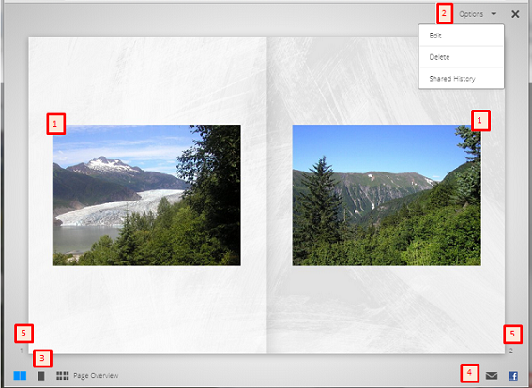

Figure 10. Photo Book – Owner View

#### UI Components

The following table provides specification for the UI components in this display.

|  |  |  |  |  |  |
| --- | --- | --- | --- | --- | --- |
|  | **Control Type** | **Text(ENG)** | **Specification Behavior** | **Tool Tip (Mouse Over)** | **Note** |
| 1 | Image |  |  |  |  |
| 2 | Pulldown | Options |  | Options |  |
|  |  | Edit | Changes to the Edit mode. Displays . | Click to edit this photo book |  |
|  |  | Delete | Changes to the Delete mode. Displays the Delete Confirm Dialog (). | Delete this photo book from your Bookshelf |  |
|  |  | Shared History | Lists persons that the user shared with via email and/or Facebook. Displays . | View shared history |  |
| 3 | Buttons |  |  |  |  |
|  |  |  | Displays a two page view. | Click to view as two pages. | User clicks: |
|  |  |  | Displays a one page view. | Click to view as a single page. | User clicks: |
|  |  | Page Overview | Displays a multi-page view of the entire Photo Book. | Click for an overview of the photo book pages. | User clicks: |
| 4 | Buttons |  |  |  |  |
|  |  | Share with email | Displays popup. | Share with email. | User clicks: |
|  |  | Share with Facebook | Displays popup login page. | Share with Facebook. | User clicks: |
| 5 | Text |  | Displays left and right Photo Book page numbers. |  | Not shown on the Photo Book cover page. |

### Non-Owner Friend’s Photo Book View

When a user shares a Photo Book with someone else the non-owner friend will be able to view the book. For example:

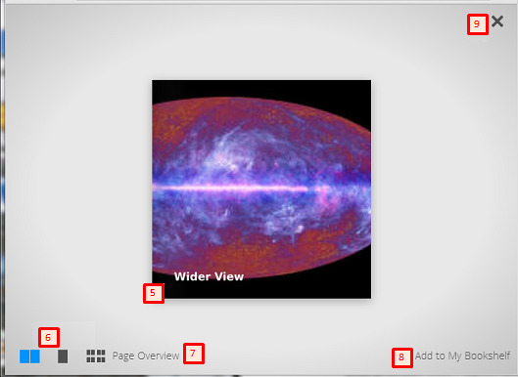

Figure 11. Photo Book - Non-Owner's View

#### UI Components

The following table provides specification for the UI components in this display.

|  |  |  |  |  |  |
| --- | --- | --- | --- | --- | --- |
|  | **Control Type** | **Text(ENG)** | **Specification Behavior** | **Tool Tip (Mouse Over)** | **Note** |
| 5 | Image |  | PlayMemories displays the shared Photo Book. |  |  |
| 6 | Buttons |  |  |  |  |
|  |  |  | Displays a two page view. | Click to view as two pages. | User clicks: |
|  |  |  | Displays a one page view. | Click to view as a single page. | User clicks: |
| 7 |  | Page Overview | Displays a multi-page view of the entire Photo Book. | Click for an overview of the photo book pages. | User clicks: |
| 8 | Button | Add to My Bookshelf | Adds the Photo Book to the user’s library | Click to save this photo book to your Bookshelf |  |
| 9 | Button |  | Returns the display to the Photo Book list. | Close | User clicks: |

## Photo Book Sharing – UI Displays

PlayMemories users will be able to share Photo Books via email or Facebook. This section presents UI specifications for each sharing method.

### Sharing via Email

When a user clicks the email icon on a Photo Book page a dialog form appears. For example:

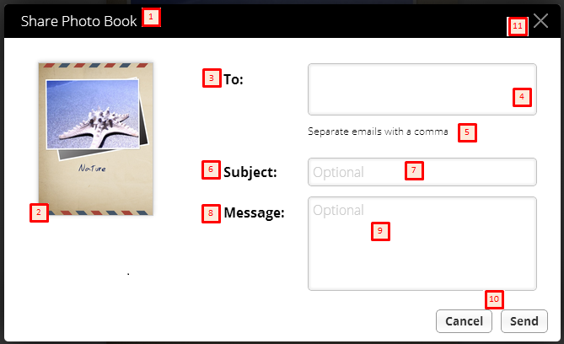

Figure 12. Share Photo Book - Email

#### UI Components

The following table provides specification for the UI components in this display.

|  |  |  |  |  |  |
| --- | --- | --- | --- | --- | --- |
|  | **Control Type** | **Text(ENG)** | **Specification Behavior** | **Tool Tip (Mouse Over)** | **Note** |
| 1 | Title Text | Share Photo Book |  |  |  |
| 2 | Image |  |  |  | Thumbnail image of the cover page for the selected Photo Book. |
| 3 | Text | To |  |  |  |
| 4 | Text Box |  |  |  | One or more email addresses separated by commas. |
| 5 | Text | Separate emails with a comma |  |  |  |
| 6 | Text | Subject |  |  | Optional |
| 7 | Text box |  |  |  | Optional |
| 8 | Text | Message |  |  |  |
| 9 | Text box |  |  |  |  |
| 10 | Buttons |  |  |  |  |
|  |  | Cancel | Closes the email dialog. | Cancel |  |
|  |  | Send | Sends email to the friend stating that this Photo Book is shared. | Send |  |
| 11 | Button |  | Returns the display to the Photo Book list. |  | User clicks: |

### Sharing via Facebook

When a user clicks the Facebook icon on a Photo Book page and logs in to Facebook, the popup appears for posting the Photo Book. This page will be used to share the selected Photo Book. For example:

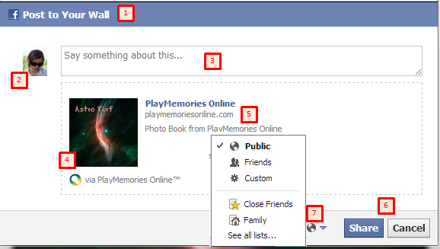

Figure 13. Share Photo Book – Facebook

#### UI Components

The following table provides specification for the UI components in this display.

|  |  |  |  |  |  |
| --- | --- | --- | --- | --- | --- |
|  | **Control Type** | **Text(ENG)** | **Specification Behavior** | **Tool Tip (Mouse Over)** | **Note** |
| 1 | Text | Post to Your Wall |  |  |  |
| 2 | Image |  |  |  | Facebook user’s avatar image. |
| 3 | Text Box | Say something about this … |  |  | User enters text that will be posted to the wall. |
| 4 | Image |  |  |  | Thumbnail image of the Photo Book cover page. |
| 5 | Text | PlayMemories Online  Via PlayMemories Online |  |  | Texts indicate that the Photo Book is obtained via PlayMemories (online, mobile, etc.) |
| 6 | Buttons |  |  |  |  |
|  |  | Share |  |  | Facebook share |
|  |  | Cancel |  |  |  |
| 7 | Button |  |  |  | Pull-down menu listing Facebook share options. |

### Manage Shared History

When a user selects Options > Share History on a Photo Book page the Manage Shared History popup appears. For example:

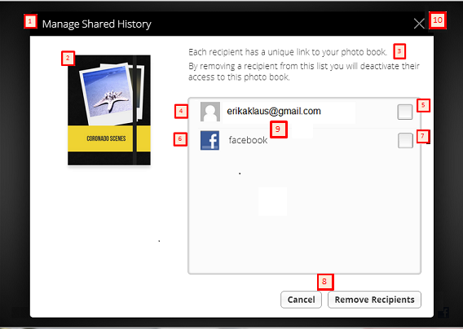

Figure 14. Manage Shared History

#### UI Components

The Photo Book Share UI components are summarized in the following table.

|  |  |  |  |  |  |
| --- | --- | --- | --- | --- | --- |
|  | **Control Type** | **Text(ENG)** | **Specification Behavior** | **Tool tip (Mouse Over)** | **Note** |
| 1 | Title bar | Manage Shared History |  |  |  |
| 2 | Image |  |  |  | Thumbnail image of the shared Photo Book. |
| 3 | Text | Each recipient has a unique link to your photo book. By removing a recipient from this list you will deactivate their access to this photo book. |  |  |  |
| 4 | Icon |  |  | Email address | Friend’s avatar image. |
| 5 | Checkbox |  |  |  | User checks to remove the user’s (email address) permission to access the Photo Book. |
| 6 | Icon |  |  | Facebook | Facebook icon. |
| 7 | Checkbox |  |  |  | User checks to remove the user’s (Facebook address) permission to access the Photo Book. |
| 8 | Buttons |  |  |  |  |
|  |  | Cancel | Closes the dialog without any updates. | Cancel |  |
|  |  | Remove Recipients | Saves the current activity status and closes the dialog. | Remove access to this photo book for the selected recipients | Activated when the user selects at least one Photo Book. |
| 9 | Text |  |  |  | “Facebook” and recipient’s Email address. |
| 10 | Button |  | Closes the dialog. |  | Reverts any checkbox deletes (adding them back to the recipient list) that the user has performed during this session. |

## Photo Book Editing – UI Displays

A user will able to edit a Photo Book after it’s completed. When the user clicks the Edit link, the page will change. See below.

**Note**: The Edit Photo Book display also appears when the user clicks the Delete link in the Options pull-down menu for .

### Edit Photo Book Page

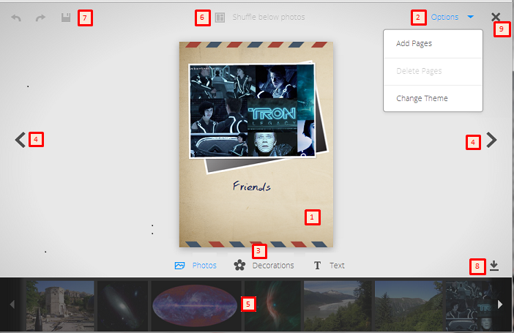

Figure 15. Photo Book – Edit Display

#### Clicking Photo Book Cover Page Thumbnail

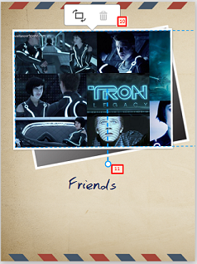

#### Clicking Select Decorations

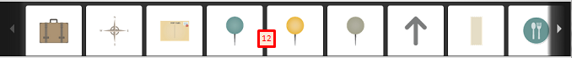

#### Clicking Select Text

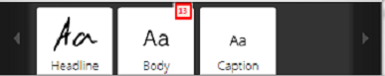

#### Clicking Cover Page Text

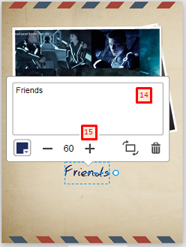

#### Selecting a Font Color

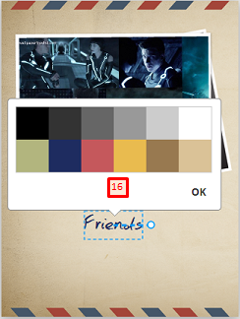

#### Changing Theme

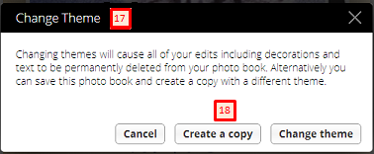

Figure 16. Photo Book - Edit – Change Theme

#### UI Components

The following table provides specification for the UI components in this display.

|  |  |  |  |  |  |  |
| --- | --- | --- | --- | --- | --- | --- |
|  | **Control Type** | **Text(ENG)** | **Specification Behavior** | **Tool Tip (Mouse Over)** | **Keyboard Shortcut** | **Notes** |
| 1 | Image |  | Shows cover page of the new Photo Book |  |  | See . |
| 2 | Pulldown | Options | Pull down menu shows options list. | Options |  |  |
|  |  | Add Pages | Adds two pages after the current page. |  |  | The Photo Book is opens to the first blank page. |
|  |  | Delete Pages |  |  |  | Selected page disappears and the display returns to the cover page. |
|  |  | Change Theme |  | Click here to select another theme |  | See . |
| 3 | Buttons | Photos |  | Select Photos |  |  |
|  |  | Decorations |  | Select Decorations |  | See . |
|  |  | Text |  | Select Text |  | See . Users select Headline, Body, or Caption text styles. |
| 4 | Button |  | Moves activity to the previous page of the Photo Book. | Previous Page |  | User clicks: |
| 4 | Button |  | Moves activity to the next page of the Photo Book. | Next Page |  | User clicks: |
| 5 | Filmstrip |  | Photos that are used in Photo Books are dimmed. | Photo already used  Drag this photo to add |  | Users can drag and drop pictures from this strip into the Photo Book. |
| 6 | Text | Shuffle below photos | Runs PhotobookCreator to shuffle the layout sequence of photos in the Photo Book. | Shuffle Layout |  | User clicks: |
| 7 | Buttons |  |  | Save Photo Book |  | User clicks:  Spinner animation runs during saving operation. |
|  |  |  | Starts a Redo operation. | Redo | Ctlr+Y | User clicks: |
|  |  |  | Starts an Undo operation. | Undo | Ctrl+Z | User clicks: |
| 8 | Button |  | Shows and hides the tray at the bottom of the page. | Show/Hide Tray |  | User clicks: |
| 9 | Button |  | Returns display to the . |  |  | User clicks: |
| 10 | Button |  |  |  |  | See . |
|  |  |  | Rotates the photo 90 degrees clockwise. | Rotate 90 degrees clockwise |  | Displayed when the user clicks: |
|  |  |  | Deletes the photo. | Delete |  | Displayed when the user clicks: |
| 11 | Resize Bar |  |  |  |  | Resize bar appears when the user clicks the Photo Book image. The bar disappears when the user clicks outside of the book. |
| 12 | Filmstrip |  |  | Drag and drop this to the page to add |  | Filmstrip of optional decoration shown at the bottom of the page. Users can drag and drop decorations into Photo Book. |
| 13 | Filmstrip |  |  | Drag and drop this to the page to add |  | Filmstrip of optional text styles shown at the bottom of the page. In this release, users may select Headline, Body, or Users can drag and drop text styles into Photo Book. |
| 14 | Text Area |  | Users enter text into this area. |  |  | See . |
| 15 | Buttons |  |  |  |  | See . |
|  |  |  | Changes font size. Displays size number change. | Decrease the font size |  | User clicks: |
|  |  |  | Changes font size. Displays size number change. | Increase the font size |  | User clicks: |
|  |  |  | Rotates the photo image clockwise. | Rotate 90 degrees clockwise |  | User clicks: |
|  |  |  | Removes text. | Delete |  | User clicks: |
| 16 | Button |  | Displays a color pallet. | Select a font color |  | User clicks: |
| 17 | Text | Change Theme |  |  |  |  |
| 18 | Buttons | Cancel |  | Cancel |  | User clicks: |
|  |  | Create a copy |  | Save this photo and create a copy |  | User clicks: |
|  |  | Change theme |  | Change theme and delete decorations |  | User clicks: |

## Photo Book Deleting – UI Displays

PlayMemories will enable users to delete Photo Books. The user selects a single displayed Photo Book or choses among the list of all books.

### Selecting and Deleting a Photo Book

When a user selects a Photo Book and clicks Delete (Options pull-down menu) a prompt appears. For example:

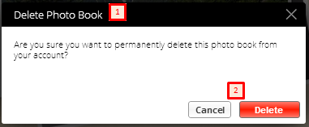

Figure 17. Delete Photo Book Prompt

#### UI Components

The following table provides specification for the UI components in this display.

|  |  |  |  |  |  |
| --- | --- | --- | --- | --- | --- |
|  | **Control Type** | **Text(ENG)** | **Specification Behavior** | **Tool Tip (Mouse Over)** | **Note** |
| 1 | Title Bar | Delete Photo Book |  |  |  |
| 2 | Buttons |  |  |  |  |
|  |  | Cancel | Returns to the view Photo Book display. This list includes the selected Photo Book. | Cancel |  |
|  |  | Delete | Deletes the Photo Book and returns the display to the Photo Book list. The list does not include the selected Photo Book. | Delete |  |

### Selecting Any or All Photo Books for Deletion

When the user clicks the red Delete Photo Books link on the All Photo Books page the display changes to show selection checkboxes. For example:

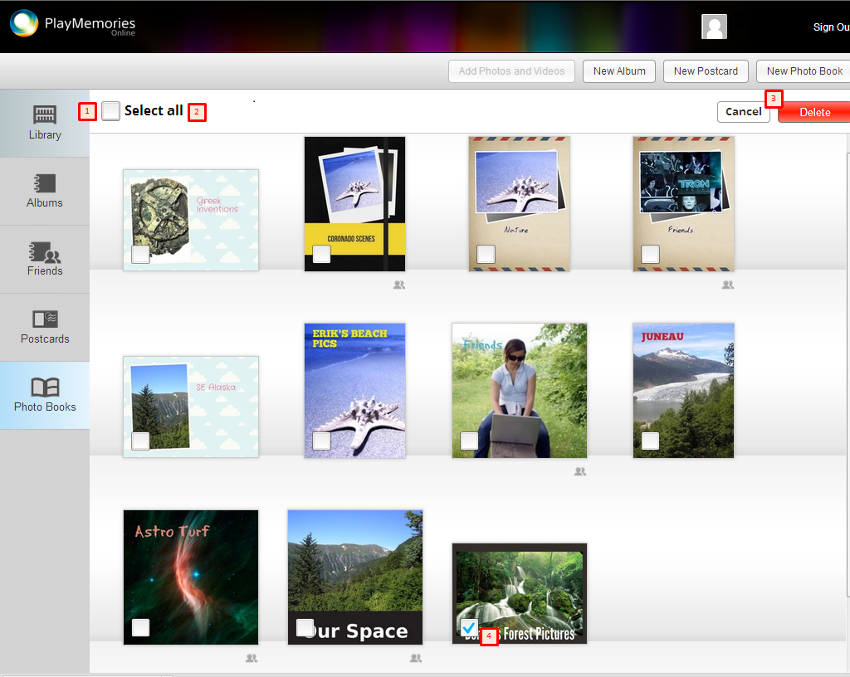

Figure 18. Photo Book - List for Deletion

#### UI Components

The following table provides specification for the UI components in this display.

|  |  |  |  |  |  |
| --- | --- | --- | --- | --- | --- |
|  | **Control Type** | **Text(ENG)** | **Specification Behavior** | **Tool Tip (Mouse Over)** | **Note** |
| 1 | Checkbox |  | Checking selects all listed Photo Books. |  |  |
| 2 | Text | Select all |  | Select all/none of the photo books |  |
| 3 | Buttons |  |  | Cancel photo book deletion |  |
|  |  | Cancel | Returns display to normal mode. |  |  |
|  |  | Delete | Deletes the checked Photo Book(s) and returns display to normal mode. | Delete the selected photo book(s). | When the user clicks the active red button Delete button it becomes inactive and turns pale gray. |
| 4 | Checkbox |  |  |  | User checks this box to select the Photo Book for deletion. |

### Deleting Selected Photo Books

When the user checks one or more boxes and clicks the Delete button, a prompt appears. For example:

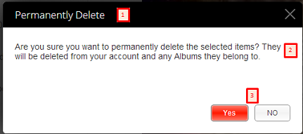

Figure 19. Photo Book - Permanently Delete Prompt

#### UI Components

The following table provides specification for the UI components in this display.

|  |  |  |  |  |  |
| --- | --- | --- | --- | --- | --- |
|  | **Control Type** | **Text(ENG)** | **Specification Behavior** | **Tool Tip (Mouse Over)** | **Note** |
| 1 | Text | Permanently Delete |  |  |  |
| 2 | Text | Are you sure you want to permanently delete the selected items?  They will be deleted from your account and any Albums they belong to. |  |  |  |
| 3 | Buttons |  |  |  |  |
|  |  | Yes | Deletes the Photo Book and returns to the Photo Book list display. |  |  |
|  |  | No | Returns to the Photo Book List display. |  |  |

# Appendix

This section provides additional information including images of default Photo Book themes, non-owner friend’s album view, and definitions of specific terms.

## A1. Photo Book Choose Album - Themes

The current PlayMemories release includes the following images for Choose Theme page options.

<images deleted here>

## A2.Terminology

This specification includes the terms defined below.

|  |  |
| --- | --- |
| **Term, Abbreviation** | **Definition** |
| Book | See Smart Photo Book. |
| Crafty | Photo Book theme<< |
| Cute | Photo Book theme |
| Day1 | First release of SmartPhoto Book (xx/xx/2013 --- TBD) |
| Image | Picture in a Photo Book Album |
| Indie | Photo Book theme |
| List | Photo Book All list |
| Modern | Photo Book theme |
| Non-Owner | PlayMemories user who views another person’s  Album or Photo Book. |
| Notebook | Photo Book theme |
| Owner | PlayMemories user who owns the Album and Photo Book. |
| PMO | PlayMemories Online |
| Retro | Photo Book theme |
| Simple | Photo Book theme |
| Smart Photo Book | Developed by UXSC, this software enables users to create, edit, view, share, and delete a Photo Book. |
| SPB | See Smart Photo Book. |
| UI | Smart Photo Book UI |

# Index

Change Theme, 28

Choose an Album, 10, 13

Choose Theme, 5, 10, 14, 16, 34

Deleting, 5, 11, 18, 19, 25, 28, 29, 30, 31, 32, 33

Permanently, 33

Editing, 6, 11, 13, 16, 19, 25, 40

Font Color, 27

Manage Shared History, 5, 19, 23

Non-Owner, 18, 20, 34

Photo Book

Decoration, 10, 11, 26, 28

Themers. *See* Themes

Photo Book Activities

Create SPB, Edit SPB, View SPB, Share SPB, Delete SPB, 10

Photo Book Activity Flow Diagram, 12

Photo Book Cover Page, 26

Photo Books

Albums, 10

Creating, 10

Listing All, 10

Play Memories URL, 6

PlayMemories

Online, Home, Studio, Mobile, 6

PlayMemories Albums, 8

PlayMemories Library, 7

PlayMemories Photo Books All, 9

Preview, 16

Sharing, 6, 11, 13, 21, 22, 23, 40

Manage Shared History, 23

Smart Photo Book, 6

ASD PlayMemories. *See* PlayMemories

SPB. *See* Smart Photo Book

Theme

Crafy, 36

Cute, 36

Indie, 37

Modern, 39

Notebook, 35

Retro, 38

Simple, 38

Travel, 34

Themes

Travel, Notebook, Cute, Crafy, Indie, Retro, Simple, Modern, 10

Thumbnails, 8, 9, 11, 17

Viewing, 7, 8, 11, 16, 17, 18, 19, 20, 31, 34, 40